EEE 120
Simulation Lab 1 Answer Sheet
Half Adder, Increment & Two’s Complement Circuit
Name:__Jason Pototsky ________
Date:____06/08/2014__________
Task 1-1: Build and Test the 1-Bit Half-Adder
Include a picture of your Logisim circuit implementation of a 1-bit half adder here:
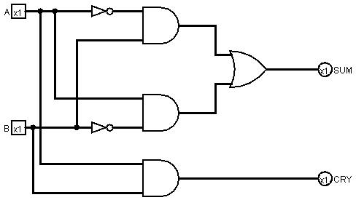
Follow the testing procedures, as outlined in the laboratory manual, and record your results in the Output columns in Error: Reference source not found. Place a mark in the checkmark column of Error: Reference source not found next to the values you tested.
HA_1 TT
Input  (Logic Values) |  | Output  (Logic Values) |  | Debug checkmark
A | B | CRY | SUM | Debug checkmark
0 | 0 | 0 | 0 | X
1 | 0 | 0 | 1 | X
0 | 1 | 0 | 1 | X
1 | 1 | 1 | 0 | X

Task 1-2: Imbed the 1-Bit Half Adder in a Subcircuit
Include a picture of your Logisim 1-bit half adder subcircuit symbol:
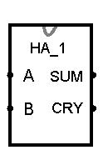

Task 1-3: Build a 4-Bit Increment Circuit
Include a picture of your Logisim circuit implementing a 4-bit increment circuit here:
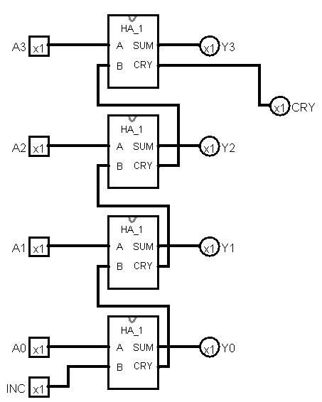

Task 1-4: Imbed 4-bit Increment Circuit in a Subcircuit
Include a picture of your Logisim 4-bit increment subcircuit symbol here:
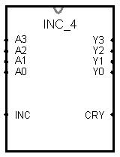
Task 1-5: Test the 4-Bit Increment Subcircuit Using Hex Numbers
Include a picture of your Logisim 4-bit increment subcircuit testing set up.
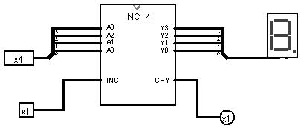
Follow the testing procedures outlined in the laboratory manual on your circuit and place your results in Table 1. Place a mark in the checkmark column of Table 1 for the values you tested.
Table 1
Input  (hex) | INC=1 Output  (hex) | INC=0 Output  (hex) | Debug checkmark
0 | 1 | 0 | X
1 | 2 | 1 | X
2 | 3 | 2 | X
3 | 4 | 3 | X
4 | 5 | 4 | X
5 | 6 | 5 | X
6 | 7 | 6 | X
7 | 8 | 7 | X
8 | 9 | 8 | X
9 | A | 9 | X
A | D | A | X
B | C | B | X
C | D | C | X
D | E | D | X
E | F | E | X
F | 0 | F | X

Task 1-6: Use INC_4 to Perform Two’s-Complement Operation
Include a picture of your Logisim two’s-complement operation circuit here:
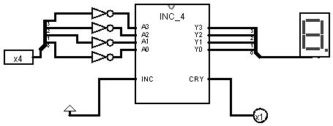

As described in your lab manual develop a sufficient set of tests that make it likely that the two’s-complement circuit is operating correctly. Explain your test plan and give justification of why successful completion of your tests makes it likely that your circuit is operating correctly. Then, record your results in Error: Reference source not found. (Note it may not be necessary to fill the entire table.)
Test plan and justification
Since I am now aware of any other method of testing I will be testing all outputs of the circuit to ensure that all outputs are adequately tested. I will additionally test to ensure that every input is correctly output the 2s compliment of the binary number. The easiest method of doing this will be to eliminate the hexadecimal display and instead use singular outputs to display binary objects. Then I will ensure that this is correct in being the input’s 2s compliment.
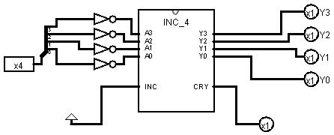

2s Compliment Test
B3 | B2 | B1 | B0 | Y3 | Y2 | Y1 | Y0 | CRY | Correct 2’s Comp
0 | 0 | 0 | 0 | 0 | 0 | 0 | 0 | 1 | N/A
0 | 0 | 0 | 1 | 1 | 1 | 1 | 1 | 0 | Y
0 | 0 | 1 | 0 | 1 | 1 | 1 | 0 | 0 | Y
0 | 0 | 1 | 1 | 1 | 1 | 0 | 1 | 0 | Y
0 | 1 | 0 | 0 | 1 | 1 | 0 | 0 | 0 | Y
0 | 1 | 0 | 1 | 1 | 0 | 1 | 1 | 0 | Y
0 | 1 | 1 | 0 | 1 | 0 | 1 | 0 | 0 | Y
0 | 1 | 1 | 1 | 1 | 0 | 0 | 1 | 0 | Y
1 | 0 | 0 | 0 | 1 | 0 | 0 | 0 | 0 | Y
1 | 0 | 0 | 1 | 0 | 1 | 1 | 1 | 0 | Y
1 | 0 | 1 | 0 | 0 | 1 | 1 | 0 | 0 | Y
1 | 0 | 1 | 1 | 0 | 1 | 0 | 1 | 0 | Y
1 | 1 | 0 | 0 | 0 | 1 | 0 | 0 | 0 | Y
1 | 1 | 0 | 1 | 0 | 0 | 1 | 1 | 0 | Y
1 | 1 | 1 | 0 | 0 | 0 | 1 | 0 | 0 | Y
1 | 1 | 1 | 1 | 0 | 0 | 0 | 1 | 0 | Y

Task 1-7: Backup Your Files
Did you backup your files to a NEW directory?
I backed up all my .cir to an archive folder on my google drive.

Simulation Lab 1: Lab Report Grade Sheet

Name: | Jason Pototsky

Instructor Assessment
Grading Criteria | Max Points | Points Lost
Template
Neatness, Clarity, and Concision | 3
Description of Assigned Tasks, Work Performed & Outcomes Met
Task 1-1: Build and Test the 1-Bit Half-Adder | 4
Task 1-2: Imbed the 1-Bit Half Adder in a Subcircuit | 3
Task 1-3: Build a 4-Bit Increment Circuit | 4
Task 1-4: Imbed 4-bit Increment Circuit in a Subcircuit | 3
Task 1-5: Test the 4-Bit Increment Using Hex Numbers | 4
Task 1-6: Use INC_4 to Perform Two’s-Complement Operation | 4
Self-Assessment Worksheet (The content of the self-assessment worksheet will not be graded. Full credit is given for including the completed worksheet.) | (2 extra points)
 | Points Lost
Lab Score | Late Lab
 | Lab Score

Self-Assessment Worksheet

Put an ‘X’s’ in the table below indicating how strongly you agree or disagree that the outcomes of the assigned tasks were achieved. Use ‘5’ to indicate that you ‘strongly agree’, ‘3’ to indicate that you are 'neutral', and ‘1’ to indicate that you ‘strongly disagree’. Use ‘NA’, ‘Not Applicable’, when the tasks you performed did not elicit this outcome. Credit may be given for including this worksheet with your lab report; however, your responses will not be graded. They are for your instructor’s information only.
Table __: Self-Assessment of Outcomes for for Simulation Lab 1: Half Adder, Increment & Two's Complement Circuit.
After completing the assigned tasks and report, I am able to: | 5 | 4 | 3 | 2 | 1 | NA
Describe the truth tables that characterize the addition of two single bit numbers. |  | X
Write the Boolean algebraic expressions that characterize the sum and carry functions for the half adder. |  |  | X
Build and debug a simulation of a circuit that will perform the half-adder operation. |  | X
Build and debug a simulation of a circuit that will perform the 4-bit increment operation. |  | X
Build and debug a simulation of a circuit that will perform the 2's-complement operation. |  | X

Write below any suggestions you have for improving this laboratory exercise so that the stated learning outcomes are achieved.

